A technology for manufacturing precision silver nanowires in large scale

CSIR-NCL has developed a technology for manufacturing precision silver nanowires in large scale. The technology has been developed by the team led by Dr. Amol A. Kulkarni from the Chemical Engineering and Process Development Division. It was carried out under the Advanced Manufacturing Technologies (AMT) initiative by the Department of Science and Technology (DST).
Currently, more than 99% of the manufacturers of these materials are outside India. In general, India imports most of the nanomaterials (except a few inorganic oxides viz. TiO2 and carbon nanomaterials). The manufacturers have evolved rapidly while developing various technologies that never existed before (viz. metal mesh technology for multi-touch screen, filters for optical components, polymer-nano composites for coatings, printable circuits, nanoceramic dental implants having, antimicrobial surface coatings, nano-diaphragms for acoustic sensing, accurate diagnosis etc.). In the recent time, silver nanowires have caught attention due to their suitability for printed and flexible electronics. It is used in the tightly controlled markets (viz. touch screen, conducting inks, thermal coatings, IR shielding sector etc.) where India has almost zero foot print. Now, with this technology developed at CSIR-NCL, Indian industries will be able to enter in the manufacturing of this precision material.
Patents have been filed to protect the technology and the product has been tested for various applications including conducting inks in various forms.
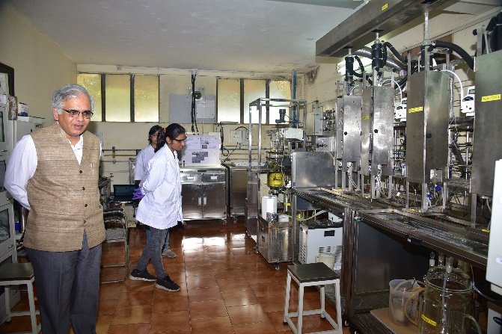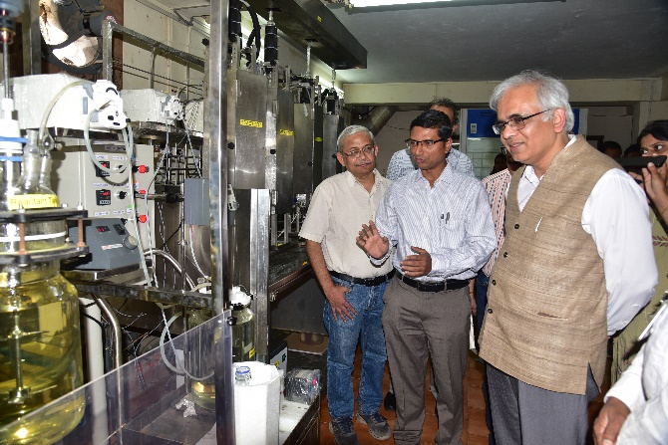
At the inaugurating the pilot

